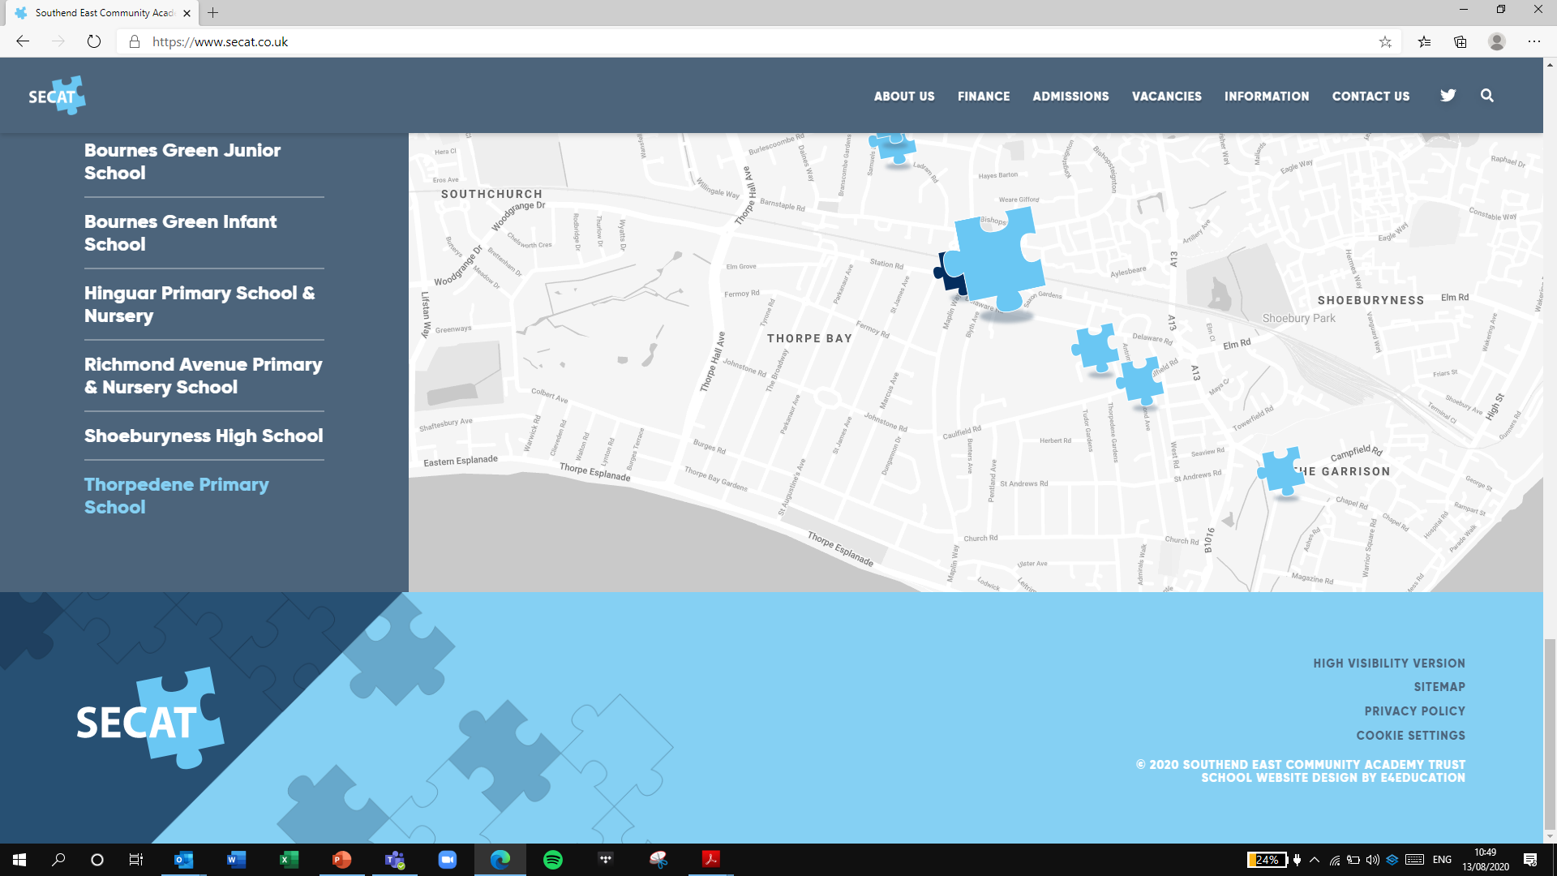
Building strong schools, Building strong partnerships, Building strong communities

SOUTHEND EAST COMMUNITY ACADEMY TRUST

Code of Conduct for Academy Committees

This Code should be read in conjunction with the articles of association and agreed scheme of delegation.
Once this code has been adopted, all Academy Committee Representatives agree to faithfully abide by it.
The following code of conduct is anchored in the Seven Nolan Principles of Public Life. It aligns with the Framework for Ethical Leadership in Education which outlines principles that support ethical decision-making and challenge unethical behaviour.
We recognise and support the principles set out in the charity governance code
We will abide by the Seven Nolan Principles of Public Life:

Selflessness
We will act solely in terms of the public interest.
Integrity
We will avoid placing ourselves under any obligation to people or organisations that might try inappropriately to influence us in our work.
We will not act or take decisions in order to gain financial or other material benefits for ourselves, our family, or our friends. We will declare and resolve any interests and relationships.
Objectivity
We will act and take decisions impartially, fairly and on merit, using the best evidence and without discrimination or bias.
Accountability
We are accountable to the public for our decisions and actions and will submit ourselves to the scrutiny necessary to ensure this.
Openness
We will act and take decisions in an open and transparent manner. Information will not be withheld from the public unless there are clear and lawful reasons for so doing.
Honesty
We will be truthful.
Leadership
We will exhibit these principles in our own behaviour. We will actively promote and robustly support the principles and be willing to challenge poor behaviour wherever it occurs.

We will apply the highest standards and will:
- act within our powers
- promote the success of the trust
- exercise independent judgement
- exercise reasonable care, skill and diligence
- avoid conflicts of interest
- not accept benefits from third parties
- declare interest in proposed transactions or arrangements
We will focus on our core purpose:
- Strategic leadership: defining a vision, fostering a culture and championing the strategy
- Accountability and assurance: providing robust and effective oversight of operations and performance
- Engagement: strategic oversight of relationships with stakeholders

As individuals, we agree to:

Fulfil our role & responsibilities
- We accept that our role is strategic and so will focus on our core purpose rather than involve ourselves in day-to-day management.
- We will fulfil our role and responsibilities as set out in our scheme of delegation.
- We will develop, share and live the ethos and values of our trust.
- We agree to adhere to trust policies and procedures.
- We shall fully cooperate with individual requests that are necessary to ensure organisational compliance, such as disclosure and barring or right to work checks.
- We will work collectively for the benefit of the trust.
- We will be candid but constructive and respectful when holding senior leaders to account.
- We will consider how our decisions may affect the trust and local community.
- We will stand by the decisions that we make as a collective.
- Where decisions and actions conflict with the Seven Principles of Public Life or may place pupils at risk, we will speak up and bring this to the attention of the relevant authorities.
- We will only speak or act on behalf of the trust board if we have the authority to do so.
- When making or responding to complaints, we will follow the established procedures.
- We will strive to uphold the trust’s reputation in our private communications (including on social media).
- We will have regard to our responsibilities under The Equality Act and will work to advance equality of opportunity for all.
- We will act as local ambassadors for our trust.

Demonstrate our commitment to the role
- We will involve ourselves actively in the work of the board and accept our fair share of responsibilities, serving on committees or working groups where required.
- We will make every effort to attend all meetings and where we cannot attend explain in advance why we are unable to.
- We will arrive at meetings prepared, having read all papers in advance, ready to make a positive contribution and observe protocol.
- We will get to know the school/s well and welcome opportunities to be involved in school activities.
- We will visit the school/s and when doing so will make arrangements with relevant staff in advance and observe school and board protocol.
- When visiting a school in a personal capacity (for example, as a parent or carer), we will continue to honour the commitments made in this code.
- We will participate in induction training, prioritise training in required areas (such as safeguarding) and commit to developing our individual and collective skills and knowledge on an ongoing basis.

Build and maintain relationships
- We will develop effective working relationships with leaders, staff, parents and other relevant stakeholders from our local communities.
- We will champion the voices of our school community and stakeholders.
- We will establish effective working relationships with trustees.
- We will express views openly, courteously and respectfully in all our communications with board members and staff both inside and outside of meetings.
- We will work to create an inclusive environment where each board member’s contributions are valued equally.
- We will support the chair in their role of leading the board and ensuring appropriate conduct.

Respect confidentiality
- We will observe complete confidentiality both inside and outside of the trust when matters are deemed confidential or where they concern individual staff, pupils or families.
- We will not reveal the details of any governing board vote.
- We will ensure all confidential papers are held and disposed of appropriately.
- We will maintain confidentiality even after we leave office.

Declare conflicts of interest and be transparent
- We will declare any business, personal or other interest that we have in connection with the board’s business, and these will be recorded in the register of business interests.
- We will also declare any conflict of loyalty at the start of any meeting should the need arise.
- If a conflicted matter arises in a meeting, we will offer to leave the meeting for the duration of the discussion and any subsequent vote.
- We accept that the Register of Business Interests will be published on the trust’s website.
- We will act as a trustee/academy committee member; not as a representative of any group.
- We accept that in the interests of open governance, our full names, date of appointment, terms of office, roles on the trust board, attendance records, relevant business and pecuniary interests, category of governor/trustee and the body responsible for appointing us will be published on the trust website.
- We accept that information relating to board members will be collected and recorded on the DfE’s national database (Get information about schools), some of which will be publicly available.
We understand that potential or perceived breaches of this code will be taken seriously and that a breach could lead to formal sanctions.

Adopted by: SECAT Trust Board on 11th September 2023
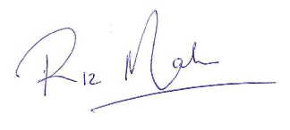
Signed: Chair of SECAT Trust Board

The SECAT Trust Board agree that this code of conduct will be reviewed annually and endorsed by the full Trust Board.

Name…………………………………………………..

Signed………………………………………………….

Date………………………………………………………

