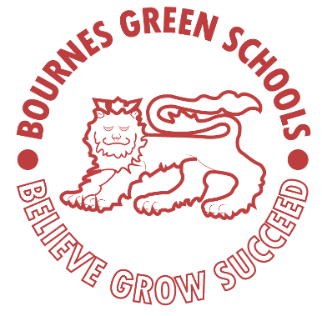 | Bournes Green Schools  Our School Rules

Green is Great!

- Follow instructions.
- Speak and listen respectfully.
- Use kind hands, kind feet and a kind face.
- Always try your best.
- Work together.

Bournes Green Schools

Believe, Grow, Succeed
 |  | Believe - We believe in ourselves and others in all that we do, even when we face a challenge.  Grow - We grow as individuals and become better people in every way. We take great pride in helping others grow.  Succeed - We always try our best. We celebrate our, and other’s successes, inside and outside of school, and are proud of every achievement

