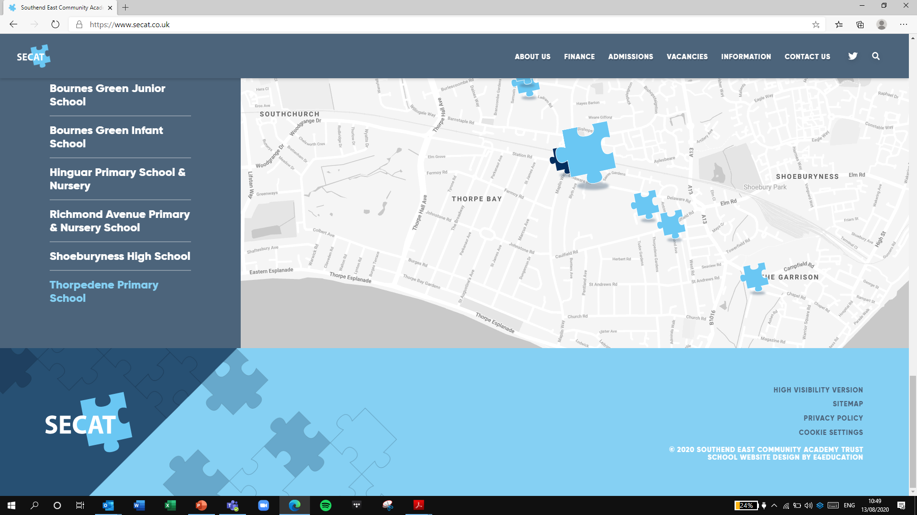
Building Strong Schools
Building Strong Partnership
Building Strong Communities
SOUTHEND EAST COMMUNITY ACADEMY TRUST

Volunteer Application Form

Please complete the application form in full.
Please note that the Trust/School may not be able to accommodate all preferences.
Data protection notice
Throughout this form, we ask for some personal data about you. We’ll only use this data in line with data protection legislation and process your data for one or more of the following reasons permitted in law:
- You’ve given us your consent
- We must process it to comply with our legal obligations

You’ll find more information on how we use your personal data in our privacy notice for volunteers.

Personal details
Name:
Date of birth:
Telephone number:
Email address:
Home address:
Emergency Contact Name:
Relationship to you:
Contact Number:

Disclosure and Barring Service (DBS) information
The school/trust is legally obligated to process an enhanced Disclosure and Barring Service (DBS) check before making appointments to relevant posts.
The enhanced DBS check will reveal both spent and unspent convictions, cautions, reprimands and final warnings, and any other information held by local police that’s considered relevant to the role. Any information that is “protected” under the Rehabilitation of Offenders Act 1974 (Exceptions) Order 1975 will not appear on a DBS certificate.
Volunteers working in regulated activity will also require a barred list check.
Any data processed as part of the DBS check will be processed in accordance with data protection regulations and the school’s/trust’s privacy notice.
Do you have a DBS check? (please circle) | Yes/No
If yes, what type of check do you have? (please circle) | Basic DBS / Standard DBS / Enhanced DBS / Enhanced DBS with barred list information
Date of check:
Certificate number:

Availability
 | Monday | Tuesday | Wednesday | Thursday | Friday
AM
PM
Before school
After school
Lunchtimes
How many hours per week/month can you volunteer?
Can you commit to at least one term?
Experience and qualifications
Do you have experience working as a volunteer, especially with children? If yes, please include details in the box below.
Why would you like to volunteer?
Do you have any particular skills, employment experience or hobbies you would like to share with the school?(For example, languages spoken, sports, scouting, etc.)
Do you have any relevant qualifications?

Preferences
Which school would you like to volunteer at?
What age group/department would you prefer to work with?
Would you prefer to work 1-on-1 or with a
small group?

References
Your placement as a volunteer may be subject to satisfactory references. Please give the details of two referees who can comment on your suitability (e.g. employers, colleagues, teachers, etc.).
Name: | Name:
Relationship to you: | Relationship to you:
Address: | Address:
Telephone number: | Telephone number:
Email address: | Email address:

Disability and accessibility
The Trust is committed to ensuring that applicants with disabilities or impairments receive equal opportunities and treatment.
If you have a disability or impairment, and would like us to make adjustments or arrangements to assist you, please state the arrangements you require:

Code of Conduct for Volunteers

By signing this form, volunteers agree to the following:

- School rules and policies
  - Volunteers will follow all school rules and policies, including those on:
    - Safeguarding and Child protection
    - ICT and internet acceptable use
    - Online safety
    - Mobile phones
    - Data protection
    - Health and safety
    - Equality
    - Whistle-blowing
    - Behaviour
  - Copies of the school policies are available online or from the school office

- Professional conduct
  - Volunteers must accept and follow instructions provided by supervisors and ask for guidance or clarification if required. Questions can be directed to the supervising member of staff.
  - Behaviour management is the responsibility of school staff. If volunteers witness behaviour that is in breach of the school’s behaviour policy, or are struggling to manage the behaviour of pupils with whom they’re working, they should alert the class teacher immediately. Volunteers should not attempt to reprimand pupils or issue sanctions.
  - Volunteers must conduct themselves in a professional manner at all times. This includes:
    - Dressing in a way that is professional and appropriate to the work they are doing
    - Refraining from using inappropriate language
    - Setting an example for pupils by acting in a way that reflects the school’s ethos and values
    - Behaving in a way that is appropriate for the role they are undertaking
    - Ensuring that comments, including those made on social media, do not bring the school into disrepute
  - Volunteers must not accept gifts from, or give gifts to, pupils. The exception is small tokens, such as those exchanged at the end of term or as a way of saying “thank you”.
  - Volunteers must not transport pupils in their own cars unless specific arrangements have been made with the school, and the pupil’s parents have consented.
  - Parent volunteers with children at the school must not act in a way that favours their own child,and should not approach their child unnecessarily during the school day (for instance, during break times). They may not use their time as a volunteer to discuss their child’s education with school staff.
  - If a volunteer is unable to come to school when they are expected/scheduled to be in, they must contact their supervisor or the school office as soon as possible. Inconsistent attendance may result in the placement being reviewed or terminated.

- Safeguarding
  - Volunteers must be familiar with, and adhere to, the school’s safeguarding and child protection policy. Safeguarding training will be provided to all volunteers before they begin their placement.
  - If volunteers have concerns about the welfare of a child, or if a child makes a disclosure, they should speak directly to the designated safeguarding lead (DSL) or deputy DSL within the school.
  - Volunteers should refrain from physical contact with pupils and should use their judgement to determine when physical contact is appropriate. If physical contact with pupils is required, volunteers should ask for a pupil’s consent before touching them.
  - Volunteers must alert the DSL if a pupil develops an infatuation with them, and must not form personal relationships with pupils, either inside or outside of school, with whom they do not already have a personal relationship. This includes:
    - Exchanging contact information
    - Making contact with pupils outside of school, including on social media
    - Arranging to meet pupils outside of school
    - Volunteers should not take or share photos of pupils unless instructed to do so by their supervisor.

- Health and safety
  - Volunteers must abide by the school’s health and safety and first aid policies. Volunteers are not to administer first aid, except in an emergency where none of the designated first aiders are available.
  - Volunteers must be familiar with the school’s fire safety and emergency evacuation procedures.
  - Volunteers must sign in and sign out at the beginning and end of every visit, and must wear a visitor badge at all times.

- Confidentiality
  - Information about pupils, parents and staff at the school is confidential, and should not be shared with anyone else. Volunteers shouldn’t discuss pupils with parents or other children. If parents approach volunteers for information, they should be directed to speak to a class teacher or the headteacher.

Failure to adhere to this code of conduct may result in the termination of the placement. In more serious cases, misconduct will be treated in line with the Staff Disciplinary Policy.

Please sign and date below:

Volunteer Name: ………………………………………………………………………….…………..

Signature: …………………………………………………………………. Date: …………………

